Meme Gen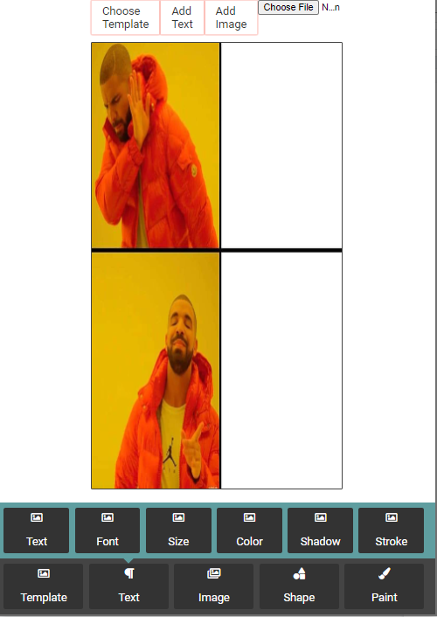

Current Interface while Building

Main Menu Slider

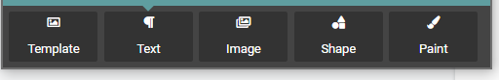

Font Properties

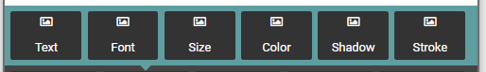

**MainMenu :: Text ( #dialogFont )**

Used to show the Font Properties

Initialized in ***script.js::153***

Click Event ***script.js::107***

**FontProperties :: Text ( #addText )**

Used to input Text on Canvas

Initialized ***script.js::154***

Click Event ***script.js::78***

**FontProperties :: Font( #chnageFont )**

Used to Change Font Family

Initialized ***script.js::161***

Click Event ***script.js::117***

**FontProperties :: Size( #changeSize )**

Used to Change font Size

Click Event ***script.js::126***

**FontProperties :: Size( #changeColor )**

Used to Change font Size

Init ***colorPicker.js :: 1***

Input Event ***colorPicker.js :: 28***

Change Event ***colorPicker.js :: 37***

**Input Dialog Overlay**

**(ido)**

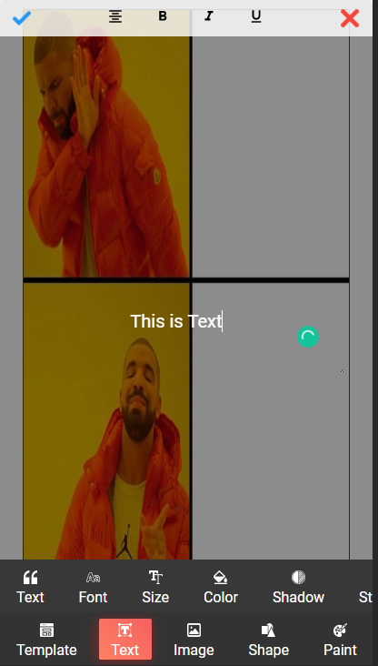

HTML Layout:

#ido_main

#formatingArea

img -> #ido_ok

#formatingBtns

img -> #formatingArea-center

img -> #formatingArea-bold

img -> #formatingArea-italic

img -> #formatingArea-underline

img -> #ido_close

textarea -> #ido_Text